1.
#include <iostream>
#include <cstring>
using namespace std;

class Student {
private:
int rollNo;
char sName[20];
char sCourse[20];

public:
Student() {
rollNo = 0;
sName[0] = '\0';
sCourse[0] = '\0';
}

Student(int roll, const char *name, const char *course) : rollNo(roll) {
strcpy(sName, name);
strcpy(sCourse, course);
}

int getRollNo() {
return rollNo;
}

char* getSName() {
return sName;
}

void setStudentInfo() {
cout << "Enter the student roll no: " << endl;
cin >> rollNo;

cout << "Enter the student name: " << endl;
cin >> sName;

cout << "Enter the course name: " << endl;
cin >> sCourse;
}

void display() {
cout << "Student roll No: " << rollNo << ", Student name: " << sName << ", Course: " << sCourse << endl;
}
};

void findStudent(int roll, Student *s) {
for (int i = 0; i < 2; i++) {
if (s[i].getRollNo() == roll) {
cout << s[i].getSName() << endl;
}
}
}

int main() {
Student s1(78, "Manoj", "AC");
s1.display();

Student *s = new Student[2];

for (int i = 0; i < 2; i++) {
s[i].setStudentInfo();
}

for (int i = 0; i < 2; i++) {
s[i].display();
}

int roll;
cout << "Enter the roll no to find student: " << endl;
cin >> roll;

findStudent(roll, s);

delete[] s;

return 0;
}
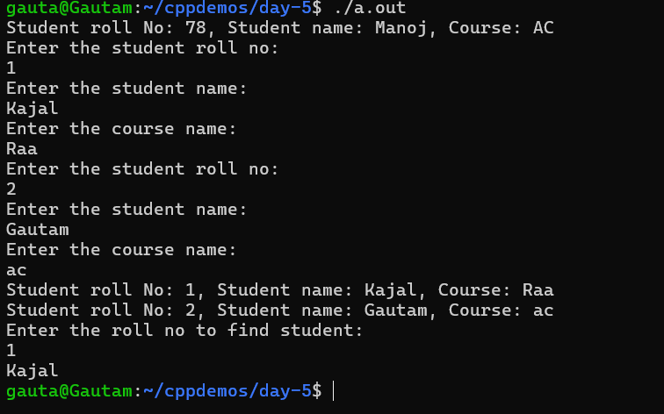
2.
#include <iostream>
using namespace std;

class Time {
private:
int hr;
int mint;
int sec;

public:
Time() {
hr = 0;
mint = 0;
sec = 0;
}

Time(int h, int m, int s) {
hr = h;
mint = m;
sec = s;
}

void setHour(int h) {
hr = h;
}

void setMint(int m) {
mint = m;
}

void setSec(int s) {
sec = s;
}

void display() {
cout << "hour: " << hr << ", minute: " << mint << "second: " << sec << endl;
}

Time operator-(const Time t1) {
long long time1 = this->hr * 3600 + this->mint * 60 + this->sec;
long long time2 = t1.hr * 3600 + t1.mint * 60 + t1.sec;

long long diff = abs(time1 - time2);

Time temp;
temp.hr = diff / 3600;
diff = diff % 3600;
temp.mint = diff / 60;
temp.sec = diff % 60;
return temp;
}

~Time() {}

static bool compare(Time t1, Time t2) {
return (t1.hr == t2.hr && t1.mint == t2.mint && t1.sec == t2.sec);
}
};

int main() {
Time t1;
Time t2(7, 32, 56);

t1.setHour(8);
t1.setMint(46);
t1.setSec(56);

t1.display();
t2.display();

Time t3 = t1 - t2;

if (Time::compare(t1, t2)) {
cout << "Times are equal." << endl;
} else {
cout << "Times are not equal." << endl;
}

t3.display();

return 0;
}

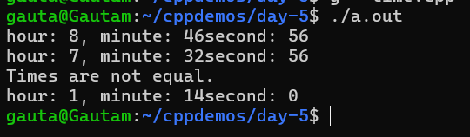
3.
dateClass.h
#ifndef DATE_H
#define DATE_H

class Date {
private:
int dd;
int mm;
int yyyy;

public:
Date();
Date(int d, int m, int y);
~Date();

void display();
bool isLeap(int y);
int daysInMonth(int m, int y);
long int totalDays();

static void getTotalDays(Date &d1, Date &d2);
bool compare(const Date d1);

Date operator-(const Date d1);
bool operator!=(const Date d1);
};

#endif

Implementation.cpp
#include <iostream>
#include "dateClass.h"
using namespace std;

Date::Date() {
dd = 0;
mm = 0;
yyyy = 0;
}

Date::Date(int d, int m, int y) {
dd = d;
mm = m;
yyyy = y;
}

Date::~Date() {}

bool Date::isLeap(int y) {
return (y % 4 == 0 && y % 100 != 0) || (y % 400 == 0);
}

int Date::daysInMonth(int m, int y) {
int days[] = {0, 31, 28, 31, 30, 31, 30, 31, 31, 30, 31, 30, 31};
if (m == 2 && isLeap(y)) return 29;
return days[m];
}

long int Date::totalDays() {
long int total = yyyy * 365L + dd;
for (int i = 0; i < yyyy; i++) if (isLeap(i)) total++;
for (int i = 1; i < mm; i++) total += daysInMonth(i, yyyy);
return total;
}

void Date::display() {
cout << "year: " << yyyy << " month: " << mm << " Day: " << dd << endl;
}

void Date::getTotalDays(Date &d1, Date &d2) {
long int diff = d1.totalDays() - d2.totalDays();
cout << "Total days Difference: " << abs(diff) << endl;
}

bool Date::compare(const Date d1) {
return (dd == d1.dd && mm == d1.mm && yyyy == d1.yyyy);
}

Main.cpp
#include <iostream>
#include "dateClass.h"
using namespace std;

int main() {
Date d1(25, 5, 2015);
Date d2(26, 9, 2019);

Date d3 = d2 - d1;
d3.display();

Date::getTotalDays(d1, d2);
if (d1 != d2) {
cout << "Dates are not equal!" << endl;
}

return 0;
}
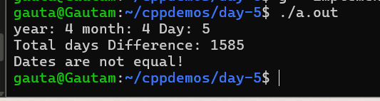

4.myString.h
#ifndef MYSTRING_H
#define MYSTRING_H

class MyString {
private:
char *p;
int size;

public:
MyString(const char *str);
MyString(const MyString& other);

void display();
~MyString();
};

#endif

myString.cpp
#include <iostream>
#include <cstring>
#include "myString.h"
using namespace std;

MyString::MyString(const MyString &other) {
size = other.size;
p = new char[size];
strcpy(p, other.p);
}

MyString::MyString(const char *str) {
size = strlen(str) + 1;
p = new char[size];
strcpy(p, str);
}

void MyString::display() {
if (p != nullptr) {
cout << p << endl;
} else {
cout << "[Empty String]" << endl;
}
}

MyString::~MyString() {
delete[] p;
}

myStringMain.cpp
#include <iostream>
#include "myString.h"
using namespace std;

int main() {
MyString s1("Kajal");
s1.display();

MyString s2 = s1;
s2.display();

return 0;
}
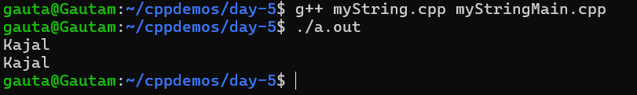

5.
Playar.h
#ifndef PLAYER_H
#define PLAYER_H

class Player {
private:
char pName[20];
int age;
char country[10];

public:
Player();
Player(const char *p, int a, const char *c);
void setPlayerInfo();
void display();
};

#endif

Player.cpp
#include <iostream>
#include <cstring>
#include "player.h"
using namespace std;

Player::Player() {
pName[0] = '\0';
age = 0;
country[0] = '\0';
}

Player::Player(const char *p, int a, const char *c) {
strcpy(pName, p);
age = a;
strcpy(country, c);
}

void Player::setPlayerInfo() {
cout << "Enter the Player Name: " << endl;
cin >> pName;

cout << "Enter the age: " << endl;
cin >> age;

cout << "Enter the country name: " << endl;
cin >> country;
}

void Player::display() {
cout << "Name: " << pName << endl;
cout << "Age: " << age << endl;
cout << "Country: " << country << endl;
}

PlayerMain.cpp
#include <iostream>
#include "player.h"
using namespace std;

int main() {
Player p1("Manoj", 23, "India");
Player p2("Shyam", 24, "India");

p1.display();
p2.display();

Player *p = new Player[2];

for (int i = 0; i < 2; i++) {
cout << "Enter " << i + 1 << " no player info: " << endl;
p[i].setPlayerInfo();
}

for (int i = 0; i < 2; i++) {
p[i].display();
}

return 0;
}
